**Course Name**



# Why Take This Course

* Global innovations in the field of artificial intelligence (AI) are going to redefine virtually every aspect of our lives.
* Students who master AI skills today will play a critical role in helping

determine how this incredible technology impacts our future.

* This course will introduce you to the broad field of artificial intelligence, and prepare you for a wide variety of opportunities in the AI field.

## IT 228: Artificial Intelligence

***Credits: 3 Lecture Hours: 48***

### Course Objectives

* + This module aims to provide the students with the basic foundation on concepts of searching and knowledge representation in AI systems.
  + The key objective is to make students more pragmatic in knowledge of AI by giving its applications like designing and training Artificial Neural Networks along with additional laboratory works.

### Course Description

* + Introduction, Agents and Environments, Informed and Uninformed Search, Knowledge Representation, Learning, Applications of AI, Production Systems, Uncertainty in AI.

# Course Details

### Unit 1: Introduction LH 4

* + 1.1 What is AI?
    - 1.1.1 Turing test approach: Chinese room argument
    - 1.1.2 Cognitive approach
    - 1.1.3 Laws of thought approach
    - 1.1.4 Rational agent approach
  + 1.2 Difference between AI and Omniscience

### Unit 2: Agents and Environments LH 7

* + 2.1 Agent, Rational agent, and Intelligent Agent
  + 2.2 Relationship between agents and environments
  + 2.3 Environments and its properties(Fully observable vs. partially observable, single agent vs. multi-agent, deterministic vs. stochastic, episodic vs. sequential, static vs. dynamic, discrete vs. continuous, known vs. unknown)
  + 2.4 Agent structures
    - 2.4.1 Simple reflex agents
    - 2.4.2 Model-based reflex agents
    - 2.4.3 Goal-based agents
    - 2.4.4 Utility-based agents
    - 2.4.5 Learning agents
  + 2.5 Performance evaluation of agents: PEAS description
* **Unit 3: Informed and Uninformed Search LH 8**
  + 3.1 Why search in AI?
  + 3.2 Blind search (Un-informed search)
    - 3.2.1 Breadth first search (BFS)
      * **Variations: Uniform cost search**
    - 3.2.2 Depth first search (DFS)
      * **Variations: Depth limited search, Iterative deepening DFS**
  + 3.3 Heuristic search (Informed search)
    - 3.3.1 Hill climbing
      * The Foothills Problem
      * The Plateau Problem
      * The Ridge Problem
    - 3.3.2 Greedy (Best-first) search
    - 3.3.3 A* algorithm search
    - 3.3.4 Means-Ends Analysis: Household ROBOT, Monkey Banana Problem

##### Unit 3: Informed and Uninformed Search contd…

* + 3.4 General Problem Solving (GPS): Problem solving agents
    - 3.4.1 Constraint satisfaction problem
      * Constraint Satisfaction Search
      * AND/OR trees
      * The bidirectional search
      * Crypto-arithmatic
  + 3.5 Game playing and AI
    - 3.2.1 Game Trees and Mini-max Evaluation
    - 3.2.2 Heuristic Evaluation
    - 3.2.3 Min-max algorithm (search)
    - 3.2.4 Min-max with alpha-beta
    - 3.2.5 Games of chance
    - 3.2.6 Game theory
* **Unit 4: Knowledge Representation LH 8**
  + 4.1 Logic
    - 4.1.1 Propositional Logic
      * 4.1.1.1. Syntax, semantics, and properties
      * 4.1.1.2. Conjunctive Normal Form (CNF)
      * 4.1.1.3. Disjunctive Normal Form (DNF)
      * 4.1.1.4. Inference Rules
      * 4.1.1.5. Resolution
    - 4.1.2 Predicate Logic
      * 4.1.1.1. First-Order Predicate Logic (FOPL)
      * 4.1.1.2. Syntax and semantics in FOPL
      * 4.1.1.3. Quantifiers
      * 4.1.1.4. Clausal Normal Form
      * 4.1.1.5. Resolution
    - 4.1.3 Fuzzy Logics
  + 4.2 Semantic networks (nets): Introduction, and examples

|  |  |  |  |
| --- | --- | --- | --- |
| * **Unit 5: Learning** |  |  | **LH 6** |
| – 5.1 Why learning? |  |  |  |
| * 5.2 Supervised (Error based) learning   + 5.2.1 Gradient descent learning: Least | Mean | Square, | Back Propagation |

algorithm

* + - 5.2.2 Stochastic learning
  + 5.3 Unsupervised learning
    - 5.3.1 Hebbian learning algorithm
    - 5.3.2 Competitive learning
  + 5.4 Reinforced learning (output based)
  + 5.5 Genetic algorithms: operators

##### Unit 6: Applications of AI LH 5

* + 6.1 Artificial Neural Networks (ANN)
    - 6.1.1 Neural Networks (NN) and ANN
    - 6.1.2 Activation functions: unit (unary and binary), ramp, piecewise linear, & sigmoid
    - 6.1.3 Training and testing: Basic concept
    - 6.1.4 Mc-Colloch-Pits neuron model
      * 6.1.5.1. Realization of AND, OR, NOT, and XOR gates
    - 6.1.5 Neural network architectures

Single layer feed-forward architecture: ADALINE (Adaptive Linear Neuron or later Adaptive Linear Element) , Perceptron NN

* + - 6.1.6 Applications of ANN
  + 6.2 Natural Language Processing (NLP)

6.2.1 Fundamentals of language processing

### Unit 7: Production systems LH 4

* + 7.1 Strong Methods vs Weak Methods
  + 7.2 Advantages of Production Systems
  + 7.3 Production Systems and inference methods
    - 7.3.1 Conflict resolution strategies
    - 7.3.2 Forward chaining
    - 7.3.3 Backward chaining

### Unit 8: Uncertainty in AI LH 3

* + 8.1 Fuzzy sets
  + 8.2 Fuzzy logic
  + 8.3 Fuzzy inferences
  + 8.4 Probability theory and uncertainty

### Unit 9: Expert Systems Human and Machine experts LH 3

* + 9.1 Characteristics of expert systems
  + 9.2 Knowledge engineering
  + 9.3 Knowledge acquisition
  + 9.4 Classic expert system
    - 9.4.1 DENDRAL
    - 9.4.2 MYCIN
    - 9.4.3 EMYCIN
  + 9.5. Case based reasoning

### Lab Task:

* + Students are required to carry out at least 6 lab tasks on predicate

calculus, searching and neural networks using ProLog and C/C++/Java.

* + Some of the lab tasks may be on:
    - Relationship programs (e.g. mother, father, brother etc)
    - Recursive programs: Factorial, Fibonacci series etc
    - Ancestor programs
    - Tower of Hanoi (TOH) program
    - Monkey banana problem
    - Realization of logic gates (using C/C++/Java)

### Text Book:

* + Russel S. and Norvig P., **Artificial Intelligence: A modern Approach,**

##### Russel S. and Norvig P., Artificial Intelligence: A modern Approach, Prentice hallà¤à¥ à¤²à¤¾à¤à¤¿ à¤¤à¤¸à¥à¤¬à¤¿à¤° à¤ªà¤°à¤¿à¤£à¤¾à¤®Prentice hall

* + 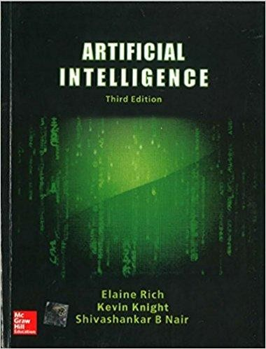Ritch and Knight, **Artificial Intelligence, Prentice hall**

### References:

* + Dan W. Patterson, **Artificial Intelligence**
  + Artificial Intelligence in the 21st century, Stephen Lucci, Danny Kopec,

Mercury Learning and

* + Information Artificial Intelligence: **Foundations of computational Agents, David L. Poole, Alan K. Mackworth, first** edtion, Cambridge University Press

**Model Question**

TRIBHUVAN UNIVERSITY FACULTY OF MANAGEMENT

Office of the Dean Full Marks: 40

2017 Time: 2 hrs.

BIM / Seventh Semester / IT 228: Artificial intelligence

Candidates are required to answer all the questions in their own words as far as practicable.

Group “A”

Brief Answer Questions: [10 X 1 = 10]

1.

2. …..

…… 10.

Group “B”

Short Answer Questions: [5 X4 = 20]

1.

2. ….

…..

5.

Group “C”

Comprehensive Questions: [2 X5 = 10]

1.

2.

(Note: The students should not limit themselves to the chapters mentioned in this Model Questions as questions can be asked from any chapter (within the syllabus) in the examination.)

**Unit 1:Introduction**



* Intelligence is:

**What is intelligence?**

* + the ability to reason
  + the ability to understand
  + the ability to create
  + the ability to Learn from experience
  + the ability to plan and execute complex tasks

#### Artificial:

* + Made as copy something like natural.

**AI programming focuses on cognitive skills that include the following:**

* **Learning. This aspect of AI programming focuses on acquiring data and creating rules for how to turn it into actionable information. The rules, which are called**[***algorithms***](https://www.techtarget.com/whatis/definition/algorithm)**, provide computing devices with step-by-step instructions for how to complete a specific task.**
* **Reasoning. This aspect of AI programming focuses on choosing the right algorithm to reach a desired outcome.**
* **Self-correction. This aspect of AI programming is designed to continually fine-tune algorithms and ensure they provide the most accurate results possible.**
* **Creativity. This aspect of AI uses neural networks, rules-based systems, statistical methods and other AI techniques to generate new images, new text, new music and new ideas.**

#### Advantages of AI

The following are some advantages of AI.

* **Good at detail-oriented jobs.** AI has proven to be as good or better than doctors at diagnosing certain cancers, including [breast cancer](https://www.nytimes.com/2023/03/05/technology/artificial-intelligence-breast-cancer-detection.html) and [melanoma](https://www.curemelanoma.org/blog/article/artificial-intelligence-and-melanoma-detection-closing-the-gaps), diabetic retinopathy,etc…
* **Reduced time for data-heavy tasks.** AI is widely used in data-heavy industries, including banking and securities, pharma and insurance, to reduce the time it takes to analyze big data sets. Financial services, for example, routinely use AI to process loan applications and detect fraud.
* **Saves labor and increases productivity.** An example here is the use of [warehouse automation](https://www.techtarget.com/searchenterpriseai/feature/How-warehouse-automation-robotics-transformed-the-supply-chain), which grew during the pandemic and is expected to increase with the integration of AI and machine learning.
* **Delivers consistent results.** The best AI translation tools deliver high levels of consistency, offering even small businesses the ability to reach customers in their native language.
* **Can improve customer satisfaction through personalization.**AI can personalize content, messaging, ads, recommendations and websites to individual customers.
* **AI-powered virtual agents are always available.** AI programs do not need to sleep or take breaks, providing 24/7 service.

#### Disadvantages of AI

The following are some disadvantages of AI.

* Expensive.
* Requires deep technical expertise.
* Limited supply of qualified workers to build AI tools.
* Reflects the biases of its training data, at scale.
* Lack of ability to generalize from one task to another.
* Eliminates human jobs, increasing unemployment rates.

## What is artificial intelligence?

* **Artificial Intelligence** is the branch of computer science concerned with making computers behave like humans.
* **John McCarthy**, who coined the term in 1956, defines it as "the science and engineering of making intelligent machines, especially intelligent computer programs."
* Major AI textbooks define artificial intelligence as "the study and design of intelligent agents," where an **intelligent agent** is a system that **perceives** its **environment** and **takes actions** which maximize its chances of success.
* The definitions of AI according to some text books are categorized into four approaches and are summarized in the table below :

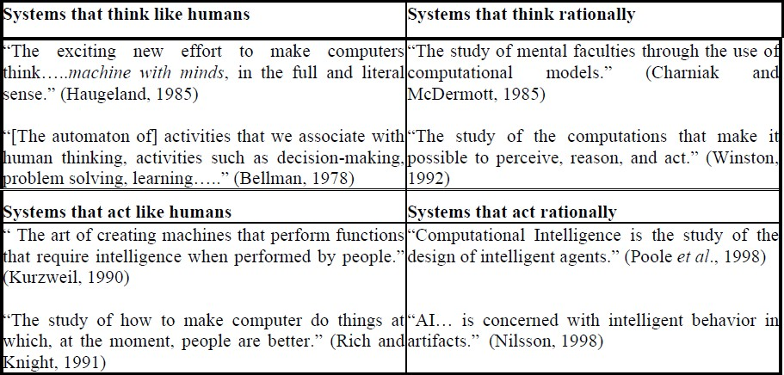

* Top dimension is concerned with thought processes and reasoning, where as bottom dimension addresses the behavior.
* The definition on the left measures the success in terms of fidelity of human performance, whereas definitions on the right measure an ideal concept of intelligence, which is called **rationality.**
* Human-centered approaches must be an empirical science, involving hypothesis and experimental confirmation.
* A rationalist approach involves a combination of mathematics and engineering.
* The four approaches in more detail are as follows :

## Acting Humanly: The Turing Test Approach

* The Turing test, proposed by Alan Turing (1950) was designed to provide a satisfactory operational definition of intelligence.
* He suggested a test based on indistinguishability from undeniably intelligent

entities- human beings.

* The test involves an interrogator who interacts with one human and one

machine.

* Within a given time the interrogator has to find out which of the two the human is, and which one the machine.
* A computer passes the test if a human interrogator after posing some written questions, cannot tell whether the written response come from human or not.

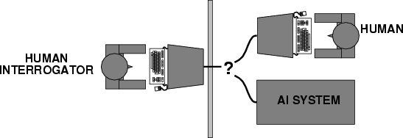

Fig: Turing Test

#### To pass a Turing test, a computer must have following capabilities:

* + **Natural Language Processing**: To enable it to communicate successfully

in English.

* + **Knowledge representation:** To store what it knows and hears.
  + **Automated reasoning:** To use the stored information to answer questions and to draw new conclusions.
  + **Machine learning:** To adapt to new circumstances and to detect and extrapolate patterns.

#### Limitations of The Turing Test Approach:

* + Turing test avoid the physical interaction with human interrogator.
  + It can not tell any thing about proficiency about the agent.

#### Total Turing Test:

* + The total Turing test includes video signals and manipulation capability so that the interrogator can test the subject„s perceptual abilities and object manipulation ability.
  + To pass the total Turing test computer must have following additional capabilities:
    - **Computer Vision**: To perceive objects
    - **Robotics**: To manipulate objects and move

John Searle

## Searle’s Chinese Room Argument

* + Famous philosopher at the University of California, Berkeley
  + Most well-known in philosophy of language, philosophy of mind and consciousness studies
  + Wrote “Minds, Brains and Programs” in 1980, which described the “Chinese Room Argument”

# Contd…

* A strong objection to the Turing test has been made by john Searle.
* According to which mental states are high level emergent features that are

caused by low level physical processes in the neurons.

* Thus, mental states cannot be duplicated just on the basis of some program having the same functional structure with the same input output behavior.
* To support his view, Searle describes a hypothetical system that is clearly running a program and passes the Turing test, But that does not understand any thing of its inputs and outputs.
* His conclusion is that running the appropriate program is not a sufficient condition for being a mind.

**Contd…**

* The system consists of a human(as CPU), who understands English but cannot understand any Chinese. He is in a room with input and output windows, and a list of rules( as a program) about manipulating Chinese characters. Chinese questions come in from the input window.
* 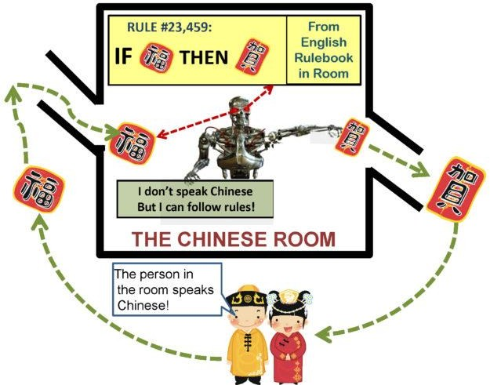Following the rules, he manipulates the characters and produces a reply, which he pushes through the output window.

# Contd…

* The Chinese answers that a person in the room produces are very good. In fact, so good, no one can tell that he is not a native Chinese speaker!
* Searle‟s Chinese Room passes the Turing Test(Intelligence test).
* Searle then argues as follows :
  + the person in the room does not understand Chinese(given). The rule book being just pieces of paper, do not understand Chinese.
  + Therefore, there is no understanding of Chinese. Hence, according to the Searle, running the right program does not necessarily generate understanding.

## Thinking Humanly: Cognitive modeling approach

* If we are going to say that a given program thinks like a human, we must have some way of determining how humans think.
* We need to get inside the actual workings of human minds. There are Three ways to do this:
  + through introspection: catch our thoughts while they go by
  + through psychological experiments: Observing a person in action and
  + through brain imaging: Observing the brain in action.
* Once we have precise theory of mind, it is possible to express the theory as a

computer program.

* But unfortunately until up to now there is no precise theory about thinking process of human brain. Therefore it is not possible to make the machine that think like human brain.

## Think rationally: The laws of thought approach

* Aristotal was one of the first who attempt to codify the “ right thinking,” that is, irrefutable reasoning processes.
* He gave Syllogisms that always yielded correct conclusion when correct

premises are given.

* Syllogism is a kind of logical argument that applies deductive reasoning to arrive at a conclusion based on two or more propositions that are assumed to be true
* For example:
  + Ram is a man
  + All men are mortal
  + Ram is mortal

# Contd…

* These law of thought were supposed to govern the operation of mind:
  + This study initiated the field of logic.
  + The logicist tradition in AI hopes to create intelligent systems using logic

programming.

* + However there are two obstacles to this approach. First, It is not easy to take informal knowledge and state in the formal terms required by logical notation, particularly when knowledge is not 100% certain.
  + Second, solving problem principally is different from doing it in practice. Even problems with certain dozens of fact may exhaust the computational resources of any computer unless it has some guidance as which reasoning step to try first.

# Acting Rationally: The rational Agent approach

* Agent is something that acts. Computer agent is expected to have following attributes:
  + Autonomous control
  + Perceiving their environment
  + Persisting over a prolonged period of time
  + Adapting to change
  + And capable of taking on another„s goal.
* **Rational behavior:** doing the right thing.
* **The right thing:** that which is expected to maximize goal achievement, given the available information.
* **Rational Agent** is one that acts so as to achieve the best outcome or, when there is

uncertainty, the best expected outcome.

* In the laws of thought approach to AI, the emphasis was given to correct inferences.
* Making correct inferences is sometimes part of being a rational agent, because one way to act rationally is to reason logically to the conclusion and act on that conclusion.
* On the other hand, there are also some ways of acting rationally that cannot be said to involve inference.
* For Example, recoiling from a hot stove is a reflex action that usually more successful than a slower action taken after careful deliberation.

#### Advantages:

* + It is more general than laws of thought approach, because correct inference is just one of several mechanisms for achieving rationality.
  + It is more amenable to scientific development than are approaches based on human behavior or human thought because the standard of rationality is clearly defined and completely general.

# Applications of AI

* What can AI do today? A concise answer is difficult, because there are so many activities in so many sub-fields. Some of its applications are as follows:
  + Autonomous planning and scheduling
  + Game playing
  + Autonomous control
  + Diagnosis
  + Logistics planning
  + Robotics
  + Speech re-cognition (Language understanding and problem solving)
  + Spam Filtering
  + Machine translation, etc.

#### Autonomous planning and scheduling:

* + AI can be used for autonomous planning and scheduling.
    - For example: NASA's Remote Agent program is the first autonomous planning program to control the scheduling of operations for a spacecraft.
    - Remote Agent generated plans from goals specified from the ground, and it monitored the operation of the spacecraft as the plans were executed.

#### Game Playing:

* + You can buy machines that can play master level chess for a few

hundred dollars. There is some AI in them.

* + IBM‟s DEEP BLUE became the first computer program to defeat the world champion in a chess match.
  + It bested Garry Kasparov(human world chess champion) by score of

3.5 to 2.5 in an exhibition match.

* + Human champions were able to draw a few matches in subsequent years, but the most recent human computer matches have been won convincingly by the computer.

#### Autonomous Control:

* + Safely driving in traffic through the streets, obeying traffic rules and

avoiding pedestrians and other vehicles.

* + NAVLAB(Navigation Laboratory) computer-controlled minivan navigate across the United States-for 2850 miles.
  + NAVLAB has video cameras that transmit road images to ALVINN, which then computes the best direction to steer, based on experience from previous training runs.
  + The ALVINN(Autonomous Land Vehicle In a Neural Network) computer vision system was trained to steer a car to keep it following a lane.

#### Diagnosis:

* + Medical diagnosis programs based on probabilistic analysis have been able to perform at the level of an expert physician in several areas of medicine.
  + For example: MYCIN diagnosed bacterial infections of the blood and suggested treatments.
  + It did better than medical students or practicing doctors.

#### Logistics Planning:

* + The AI planning techniques allowed a plan to be generated in hours that

would have taken weeks with older methods.

* + - For example: U.S. deployed a Dynamic Analysis and Re-planning Tool, DART (Cross and Walker), to do automated logistics planning and scheduling for transportation.
    - Account for starting points, destinations, routes, and conflict resolution among all parameters(vehicles, cargo, and people ).

#### Robotics:

* + AI is hugely applied in Robots that helps us to solve our complex

problems easily.

* + - For example: In Iraq and Afghanistan robots are used to handle hazardous materials, clear explosives, and identify the locations of the snipers.
    - Robots can also be used as vacuum cleaners for home use.

#### Language understanding and problem solving/ Speech recognition:

* + It is possible to instruct some computers using speech.
    - For example: A traveler calling United Airlines to book flight can have the entire conversation guided by an automated speech recognition and dialog management system,
    - This is also the example of language understanding and problem solving.
  + Most users have gone back to the keyboard and the mouse as still more

convenient.

•

#### Spam Filtering:

* + Each Day, learning algorithms classify over a billion messages as spam

saving the recipient from having to waste time.

* + Because the spammers are continually updating their tactics, it is difficult for a static programmed approach to keep up, and learning algorithms work best.

#### Machine Translation:

* + A computer program can automatically translates from one language to another, allowing the speaker in one language to understand the something expressed in another language.
  + The program uses statistical model built from examples of one language to another language translations.
  + So to understand the language the computer scientists need to understand the statistics and machine learning algorithms not the language.

#### Expert systems :

* + A ``knowledge engineer'' interviews experts in a certain domain and tries to embody their knowledge in a computer program for carrying out some task.
  + How well this works depends on whether the intellectual mechanisms required for the task are within the present state of AI.
  + For example: MYCIN, DENDRAL, PROSPECROR, etc

# Homework

* Define in your own words:
  + Intelligence
  + Artificial intelligence
  + Agent
  + rationality
  + Logical reasoning
* Differentiate between intelligence and artificial intelligence. What can AI do today?
* How is strong AI different from weak AI?
* What is Turing test? Explain its significance.
* . What is Searle‟s Chinese Room Argument? Explain in detail.
* What is AI? What are its application areas?

**Thank You !**

